4. Non-Functional Requirements

- Availability Requirements: The app will be available at near the end of the semester.
- Capacity Requirements: It will take ...GB from your device.
- Performance Requirements: There will be no loading more than 1 second.
- Portability Requirements: The app will run without Internet connection.
- Reliability Requirements: Users always can synchronize their profile, every time they connect to Internet.
- Security Requirements: Only users holding the role as “teacher” can update the levels of the users that holding the role as “student”.

5. Example Tutorials

Game 1 - World Jumble

The main menu screen.

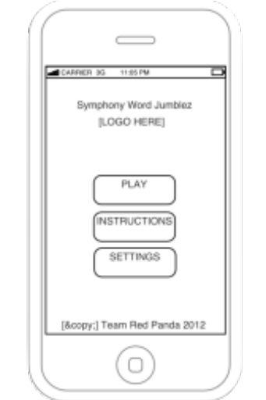(pic 1.1)
- Click Play to start the game.

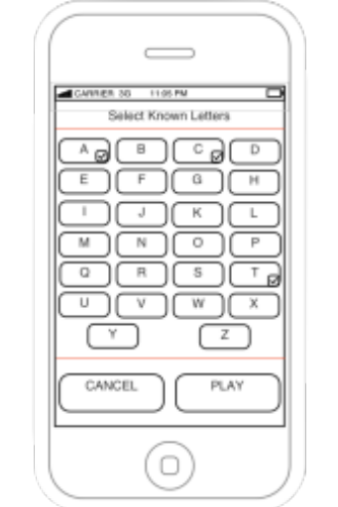(pic 1.2)
2. Select known letters. (e.g. A, C, & T)

It will show 6 randomly scrambled words from synphony.

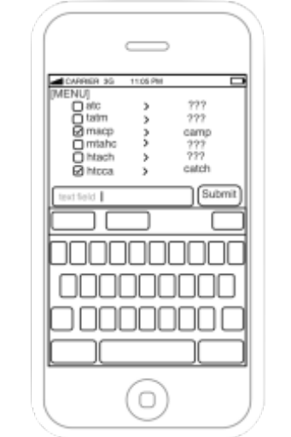(pic 1.3)
- Input the answer at the text field.
- Click on Submit or Enter
If your answer is right it will show a checkmark beside the words.

When the lesson is complete this screen will appear.
You will see your grade.

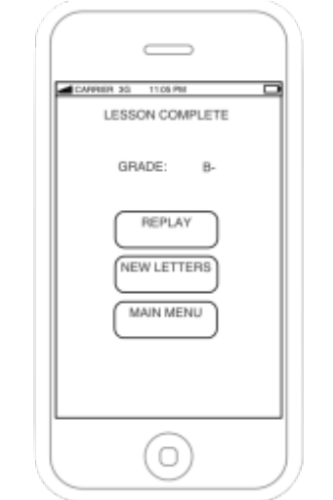(pic 1.4)
- Click Replay to try the same levels or,
- Click New Letters to select new letters. (pic 1.2)
- Click Main Menu to go back to main menu. (pic 1.1)

Game 2 - Missing Letters

The main menu screen.

(pic 2.1)
1. Click Play to start the game.

(pic 2.2)
- Select known letters. (e.g. A, C, & T)

It will show 6 words taken from synphony with a random letter removed (Only 5 shown).

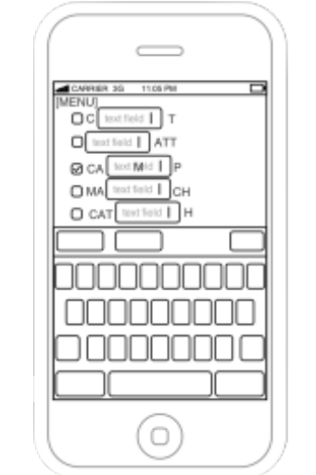(pic 2.3)
- Input the answer at the text field.
If your answer is right it will show checkmark beside the words.

When the lesson is complete this screen will appear.
You will see your grade.

(pic 2.4)
- Click Replay to try the same levels or,
- Click New Letters to select new letters. (pic 2.2)
- Click Main Menu to go back to main menu. (pic 2.1)

Instruction

If users click Instructions in the Main Menu screen, it will lead to the instructions on how to play the game.

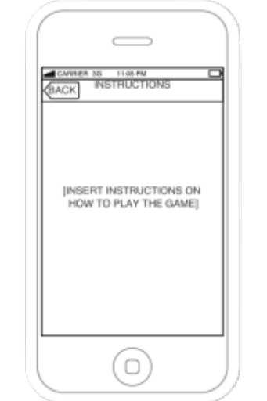(pic 3.1)

To return to the Main Menu, click the Back button.

Settings

If users click Settings in the Main Menu screen, it will lead to settings menu.

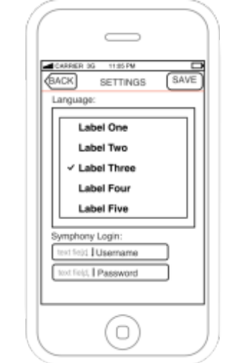(pic 4.1)
- Scroll list to select the language.
- Input Username & Password.
- Click Save.

After click Save, it will show screen (pic 1.1) or (pic 2.2).

6. Glossary

Cancel ~ to make void; to delete.
Grade ~ step in a scale, as of rank.
Instruction ~ information; orders or directions.
Login ~ the act of logging in to a database especially a multiuser computer or networked computer system.
Menu ~ any list or set of items.
Play ~ to take part or engage in a game.
Replay ~ a repetition.
Save ~ to keep from being lost.
Setting ~ make a determination.
Submit ~ to give over.

